American Society of Regional Anesthesia and Pain Medicine
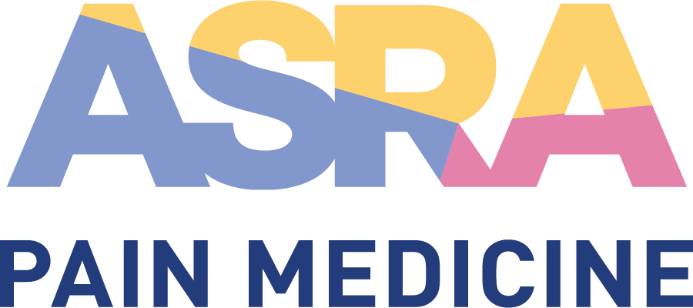

CME Policy

Attendee Expenditures and Guest Participation

Title | Attendee Expenditures and Guest Participation
Original Approval | 08/2014
Revisions | 06/2018, 06/2022

Purpose

To provide guidelines restricting ASRA Pain Medicine from using commercial support to pay attendee (non-faculty or non-ASRA Pain Medicine leadership) expenditures for participation in ASRA Pain Medicine CME activities. In keeping with the ACCME Updated Accreditation Criteria and Standards for Commercial Support (SCS 3.12), the American Medical Association’s Code of Medical Ethics, and the PhRMA Code on Interactions with Healthcare Professionals, ASRA Pain Medicine will refrain from using commercial support to pay any attendee (non-faculty or non-ASRA Pain Medicine leadership) expenditures, including travel, parking, lodging, honoraria, or other personal expenses associated with CME activity participation.

ACCME Standard for Commercial Support 3.12
The provider may not use commercial support to pay for travel, lodging, honoraria, or personal expenses for non-teacher or non-author participants of a CME activity. The provider may use commercial support to pay for travel, lodging, honoraria, or personal expenses for bona fide employees and volunteers of the provider, joint sponsor or educational partner.

PhRMA Code on Interactions with Healthcare Professionals pt. 4
Financial support should not be offered for the costs of travel, lodging, or other personal expenses of non-faculty healthcare professionals attending CME, either directly to the individuals participating in the event or indirectly to the event’s sponsor. Similarly, funding should not be offered to compensate for the time spent by healthcare professionals participating in the CME event.

AMA Code of Medical Ethics Opinion 8.061 Gifts to Physicians from Industry (5)
Subsidies from industry should not be accepted directly or indirectly to pay for the costs of travel, lodging, or other personal expenses of physicians attending conferences or meetings, nor should subsidies be accepted to compensate for the physicians’ time. Subsidies for hospitality should not be accepted outside of modest meals or social events held as a part of a conference or meeting. It is appropriate for faculty at conferences or meetings to accept reasonable honoraria and to accept reimbursement for reasonable travel, lodging, and meal expenses. It is also appropriate for consultants who provide genuine services to receive reasonable compensation and to accept reimbursement for reasonable travel, lodging, and meal expenses. Token consulting or advisory arrangements cannot be used to justify the compensation of physicians for their time or their travel, lodging, and other out-of-pocket expenses.

Policy

- Attendee Travel, Parking, Lodging, Honoraria, or Other Personal Expenses
ASRA Pain Medicine will be restricted from using commercial support to pay for any fees or expenses incurred by non-faculty or non-ASRA leadership attendees, regardless of their geographic origin. Attendees will not be compensated for their participation in an activity. All costs associated with the CME activity participation are the responsibility of the non-faculty or non-ASRA Pain Medicine leadership participant.

- Attendee Guests/Accompanying Persons
All event activities (including educational sessions, meal functions, exhibit hall, etc.) are exclusively reserved for registered attendees. Badges provided at registration are required for entrance into all functions and will be strictly enforced. Exceptions to this are as follows.
- Educational session halls: Only children who are held or harnessed (no strollers are permitted) may accompany a registered attendee. Children may not occupy a seated spot. If a child becomes a distraction to attendees, the infant must be removed from the room immediately. No children, under any circumstance, are permitted in workshops or PBLDs.
- Exhibit hall: Infant children who are held or harnessed (no strollers are permitted) may accompany a registered attendee at any time. In addition, adult children ages 21 and over may purchase a guest ticket to accompany a registered attendee during the opening network reception only.
- Saturday celebration: All children are welcome to the Saturday night celebration. Tickets must be purchased for any children over 2 years old.
- Miscellaneous: Lactation rooms will be available whenever possible. Please see program guide or registration desk for location. Please see hotel concierge for additional childcare options.
There will be no exceptions to the above for children, toddlers, or teens without prior written approval. Please send any requests to asrameetings@asra.com.

- Society Funding
In special circumstances, ASRA Pain Medicine society level funds may be used to cover attendee and guest expenses. Such funds must not have originated from industry sources. All expenditures must be approved by the Board of Directors.

- Exceptions for Medical Students, Residents, and Fellows
These guidelines do not apply to medical students, residents or fellows participating in a formal scholarship program offered as part of an ASRA Pain Medicine CME activity. The ACCME, PhRMA, and AMA allow financial assistance for medical students, residents and fellows to attend carefully selected educational conferences as long as the selection of students, residents, or fellows who will receive the funds is made by the academic or training institution.

