American Society of Regional Anesthesia and Pain Medicine
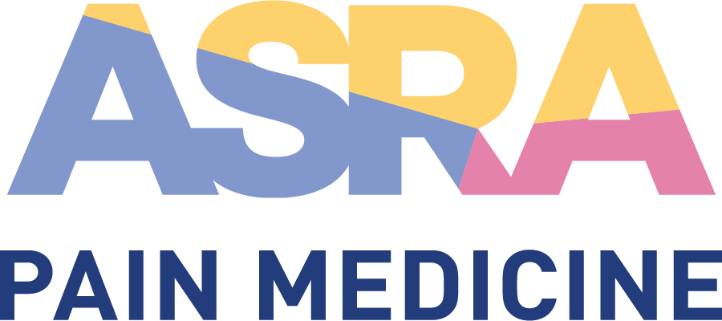

CME Policy

Photography and Recording during ASRA Pain Medicine CME Activities

Title | Photography and Recording during ASRA Pain Medicine CME Activities
Original Approval | 08/2013
Revisions | 04/2022

Purpose
Outline and communicate the right for ASRA Pain Medicine to photograph and record during educational events. Prohibit photography and recording by participants without proper pre-authorization.

Procedure

- Photography and Recording Privileges
ASRA Pain Medicine reserves exclusive rights to photograph and/or record (audio and video) all event proceedings and participants for use in marketing materials, presentations, and course content reproductions (online or other). Photography and/or recording by individuals is not permitted in the scientific, educational, and business meetings during any ASRA Pain Medicine event, unless specifically pre-authorized by ASRA Pain Medicine. Individuals granted such privileges shall be properly registered at the event and issued the proper proof of privileges (press badge or other).

This policy does not attempt to place restrictions on personal photographs including those used for social media purposes, which may paraphrase or quote content within the confines of Copyright and Fair Use.

- Communication of Policy
Notice of this policy will be included in event communications (brochure, website, program guide, walk in slides, etc.).

